- Bluebook Page114 August 2019 variant four examination:

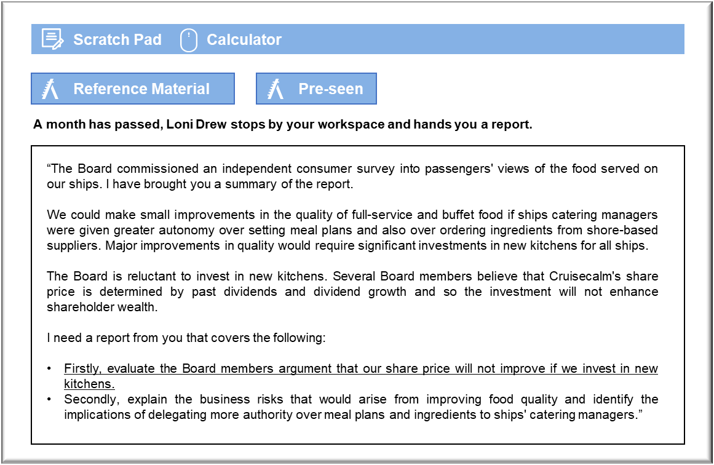MANAGEMENT CASE STUDY AUGUST 2019 EXAM ANSWERS

Variant4 Task4
These answers have been provided by CIMA for information purposes only. The answers created are indicative of a response that could be given by a good candidate. They are not to be considered exhaustive, and other appropriate relevant responses would receive credit.

CIMA will not accept challenges to these answers on the basis of academic judgement.

Requirement 1: Share price
The Board members who believe that there is a relationship between dividends, dividend growth and the share price are correct. The relationship is not, however, historical. The relationship is between expected future dividends, possibly allowing for growth, and the cost of equity. The relationship takes account of the cost of equity (ke), as required by the shareholders. The formulae effectively express the share price as the net present value of the estimated dividends that the shareholders will receive into the indefinite future.
According to this model, the new kitchens will increase Cruisecalm’s share price if they enable the company to increase its dividends in the future. Hopefully, improving the menu would increase revenues and profits, which would offer the prospect of increased dividend payments.
The additional revenues would have to exceed the additional costs, including depreciation,
before the additional dividend would be sustainable.
The investment could also reduce the cash that is available for dividends in the short term. In
that case, Cruisecalm may be forced to pay a slightly smaller dividend than had been expected, which could reduce the share price quite substantially when the dividend is announced and incorporated into the valuation model. However, the model may not be applied in such a naïve manner and the shareholders may be reassured that any short-term disappointment with the dividends will be more than offset by future dividend growth.
The model also takes account of the cost of equity. As for any exercise involving the valuation of future cash flows, the required rate of return should take account of risks. If the perceived risks associated with future dividend payments are affected by the investment in the kitchens, then the present value of the future dividends will be affected. In the context of this model, that is another way of saying that the share price will change. Overall, that complicates the implications for the share price, if this is viewed as a risky venture. Dividends will, hopefully, be expected to increase.
At the same time, they will have to be discounted at a higher required rate of return.

Food quality and delegation
The first risk is that future costs may be difficult to predict, with greater preparation time and more expensive ingredients. That could leave Cruisecalm faced with higher fixed costs associated with preparing the new food and greater volatility in ingredient prices if the ships are forced to buy higher quality ingredients. Food is already a significant element of operating costs (more than 10% of the operating costs of MV Krono and MV Batvia) and so any increase could prove problematic.
The feedback that led to the proposal to upgrade meals was based on discussions during focus groups. There is no guarantee that passengers will actually like the new menus. The suggestion is that meals are presently viewed as a little bland and boring, but such food generally lends itself to a wide audience, even if they do not particularly enjoy it. Amore adventurous menu could actually alienate some passengers, who will feel that their tastes are not being catered for, which could reduce future bookings.
Delegating meal plans could prove beneficial because the catering managers could be more
responsive to passenger feedback in the course of their cruise. The cooks on board a particular ship might be skilled at cooking a particular type of dish that is more popular with passengers than the set menu items. Care would, of course, have to be taken to ensure that all tastes are satisfied, otherwise there could be a minority of passengers who feel left out because they dislike, say, spicy food .
Delegation could also make use of the fact that the ships will be restocking with fresh produce most days. That would make it possible for the catering manager to meet with the chef and plan meals that took account of local specialities in forthcoming visits. Apart from offering a wider variety, the local produce in different ports might be cheaper than goods that have to be imported.

